**Classroom Activity: Implement E-commerce Website using ReactJS which includes Page Routing in Navbar.**

### Step 1: Ensure react-router-dom is Installed

Run the following command to install react-router-dom:

#### **Create Components:**

1. Navigate to the src folder in your project directory.
2. Create a components folder inside the src folder.
3. Create the following files inside the components folder:
   * Navbar.js
   * HomePage.js
   * ProductList.js
   * ProductDetail.js

**src/components/HomePage.js Code :**

|  |
| --- |
| import React from 'react';  const HomePage = () => {  return (  <div className="home-page">  <h1>Welcome to Our E-Commerce Site</h1>  <p>Explore our products and shop with ease.</p>  </div>  );  };  export default HomePage; |

### **src/components/ProductList.js Code :**

|  |
| --- |
| import React from 'react';  import { Link } from 'react-router-dom';  const products = [  { id: 1, name: 'Product 1', description: 'Description for Product 1' },  { id: 2, name: 'Product 2', description: 'Description for Product 2' },  // Add more products as needed  ];  const ProductList = () => {  return (  <div className="product-list">  <h1>Product List</h1>  <ul>  {products.map(product => (  <li key={product.id}>  <Link to={`/products/${product.id}`}>{product.name}</Link>  </li>  ))}  </ul>  </div>  );  };  export default ProductList; |

#### **src/components/ProductDetail.js Code ;**

|  |
| --- |
| import React from 'react';  import { useParams } from 'react-router-dom';  const products = [  { id: 1, name: 'Product 1', description: 'Description for Product 1' },  { id: 2, name: 'Product 2', description: 'Description for Product 2' },  // Add more products as needed  ];  const ProductDetail = () => {  const { id } = useParams();  const product = products.find(p => p.id === parseInt(id));  if (!product) {  return <h2>Product not found</h2>;  }  return (  <div className="product-detail">  <h1>{product.name}</h1>  <p>{product.description}</p>  </div>  );  };  export default ProductDetail; |

### Create a new CSS file named styles.css in the src folder. Add the following CSS styles to styles.css to style the navigation bar and other components:

Import the CSS file in src/index.js:

### **Styles.css code:**

|  |
| --- |
| /* styles.css */  /* Basic Reset */  * {  margin: 0;  padding: 0;  box-sizing: border-box;  }  /* Body Styling */  body {  font-family: Arial, sans-serif;  background-color: #f4f4f4;  color: #333;  }  /* Navbar Styling */  nav {  background-color: #333;  color: #fff;  padding: 10px 0;  }  nav ul {  list-style-type: none;  display: flex;  justify-content: space-around;  }  nav ul li {  margin: 0 20px;  }  nav ul li a {  color: #fff;  text-decoration: none;  font-size: 1.2em;  }  nav ul li a:hover {  text-decoration: underline;  }  /* Main Content Styling */  main {  padding: 20px;  }  /* Home Page Styling */  .home-page {  text-align: center;  }  .home-page h1 {  margin-bottom: 20px;  }  .home-page p {  font-size: 1.2em;  }  /* Product List Styling */  .product-list h1 {  margin-bottom: 20px;  }  .product-list ul {  list-style-type: none;  }  .product-list ul li {  background: #fff;  margin-bottom: 10px;  padding: 10px;  border-radius: 5px;  }  .product-list ul li a {  color: #333;  text-decoration: none;  font-weight: bold;  }  .product-list ul li a:hover {  color: #007BFF;  }  /* Product Detail Styling */  .product-detail h1 {  margin-bottom: 20px;  }  .product-detail p {  font-size: 1.1em;  } |

### **Output:**

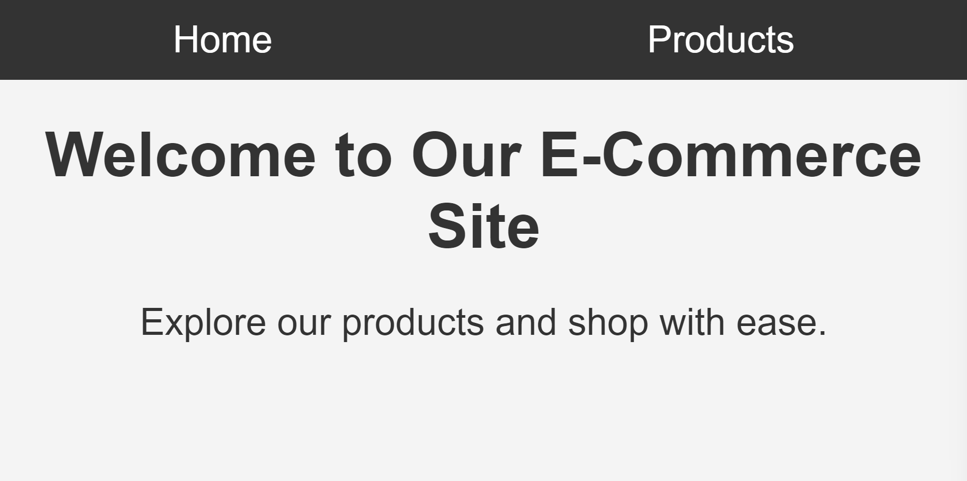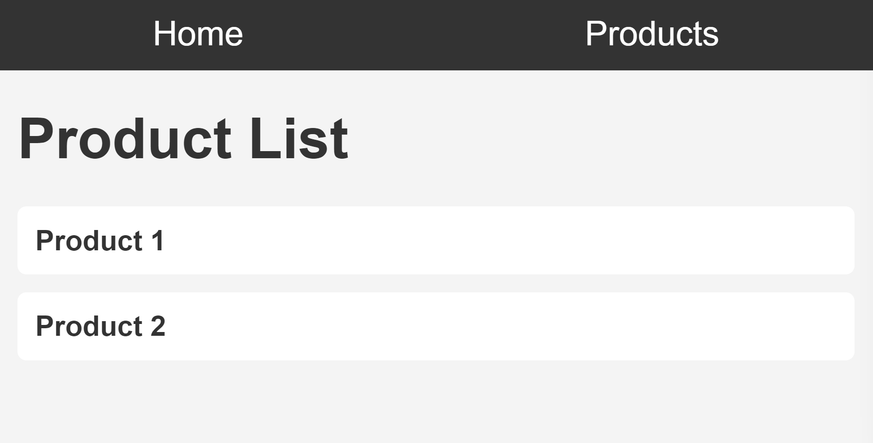

### **Execution Steps**

#### **Create CounterWithCallback.js:**

* Navigate to the src folder in your project directory.
* Create a file named CounterWithCallback.js.
* Write the code for the CounterWithCallback component in this file.

#### **2. Update App.js:**

* Replace the contents of App.js with the code to import and use the CounterWithCallback component.

#### **3. Save the Files:**

* Ensure that both CounterWithCallback.js and App.js are saved after making the changes.

#### **4. Run Your React App:**

* Open your terminal.
* Navigate to the project directory and run the command:npm start

#### **4. View the Output:**

* Open your browser and go to http://localhost:3000.
* You should see the counter with buttons to increment both the count and the value.